Software Development Week Two Assignment one

# Tasks

Select Your Operating System (OS): Choose an operating system that best suits your preferences and project requirements. Download and Install Windows 11. <https://www.microsoft.com/software-download/windows11>

To install and set up Windows 11 on your PC, follow these step-by-step instructions:

1. Check System Requirements:

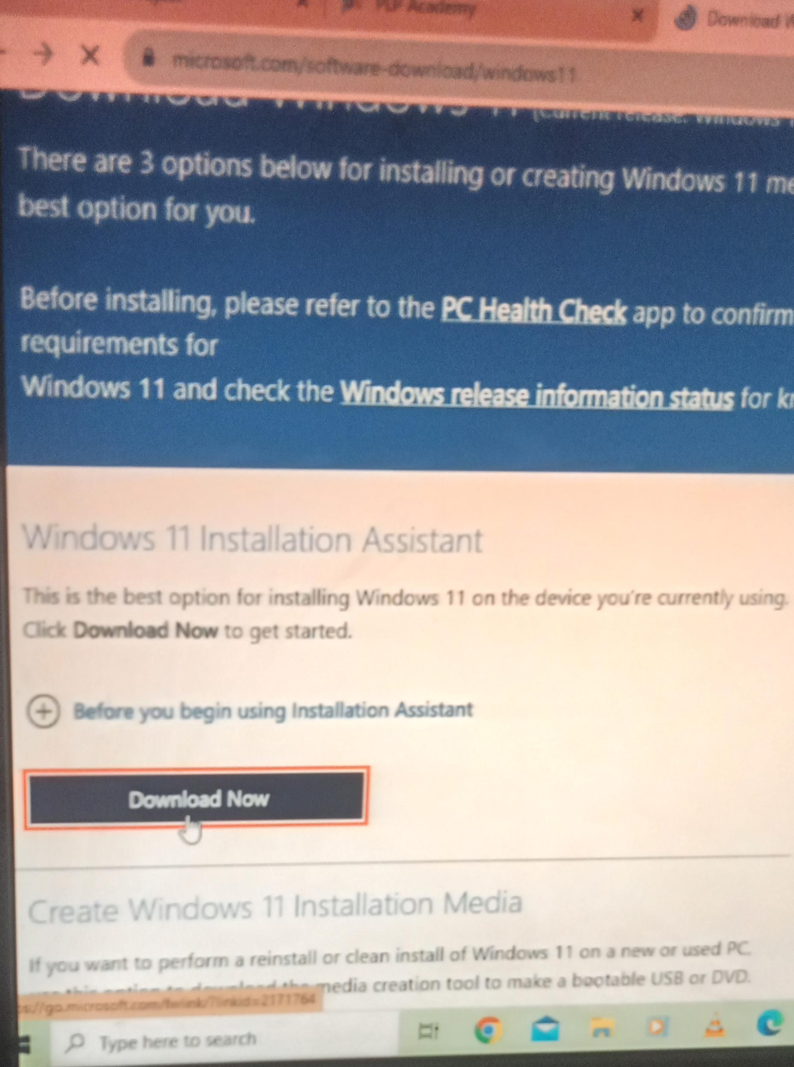 Ensure that your PC meets the minimum system requirements for Windows 11. These include processor, RAM, storage, and other hardware requirements specified by Microsoft.

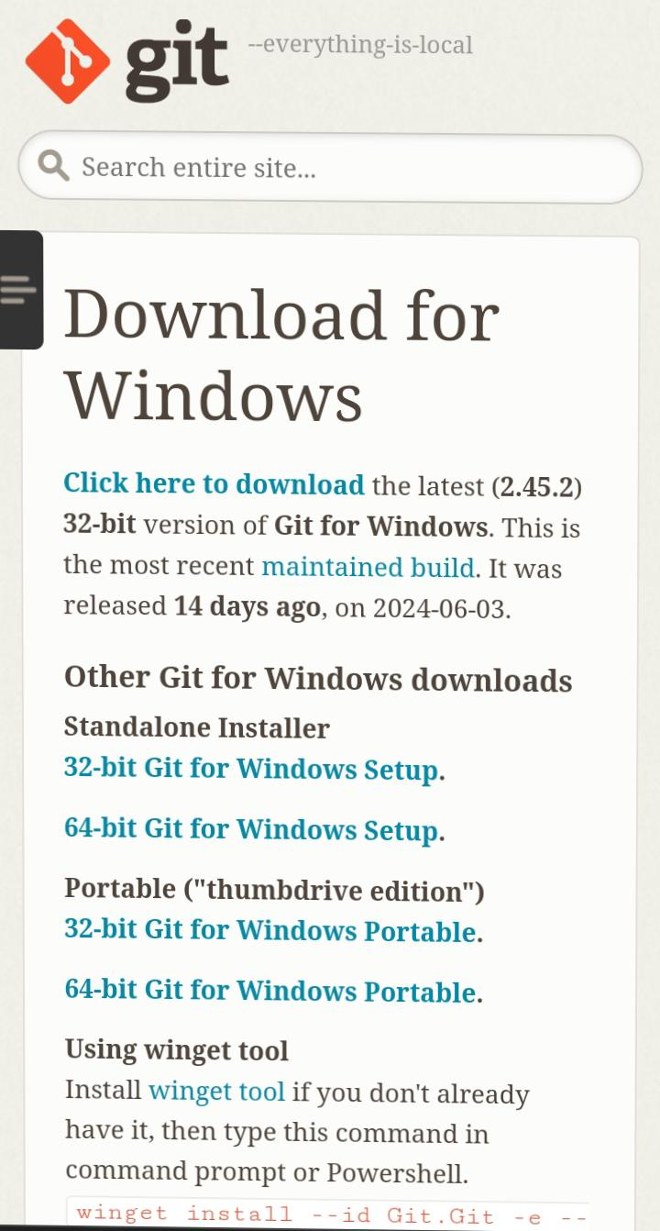

2. Create a Bootable USB Drive:

Download the Windows 11 installation media creation tool from the Microsoft website.

Run the tool and follow the on-screen instructions to create a bootable USB drive with the Windows 11 installation files.

3. *Backup Data:

- Before proceeding with the installation, it’s recommended to back up your important data to an external drive or cloud storage.

4. Access BIOS Settings:

Restart your PC and access the BIOS or UEFI settings by pressing the designated key (e.g., F2, F12, DEL) during the boot process. The key to access BIOS settings varies depending on the PC manufacturer.

5. Set Boot Priority:

In the BIOS settings, set the boot priority to boot from the USB drive first.

6. Install Windows 11:

Insert the bootable USB drive into your PC and restart the system.

Follow the on-screen instructions to begin the Windows 11 installation process.

You may be prompted to enter your product key during the installation. If you don’t have a product key, you can choose the option to activate Windows later.

7. Setup Windows 11:

Once the installation is complete, follow the on-screen prompts to set up Windows 11.

This includes choosing your region, keyboard layout, connecting to a network, and signing in with your Microsoft account or creating a local account.

8. Customize Settings:

Customize your privacy settings and other preferences as per your requirements.

9. Install Drivers and Updates:

After Windows 11 is set up, install any necessary drivers for your hardware components (e.g., graphics card, network adapter) and run Windows Update to ensure your system is up to date.

Following these steps guided me through the process of installing and setting up Windows 11 on my PC.

Install a Text Editor or Integrated Development Environment (IDE): Select and install a text editor or IDE suitable for your programming languages and workflow. Download and Install Visual Studio Code. <https://code.visualstudio.com/Download>

1. Download Visual Studio Code:

- Go to the [Visual Studio Code website](<https://code.visualstudio.com/>).

- Click on the download button for your operating system (Windows, macOS, or Linux).

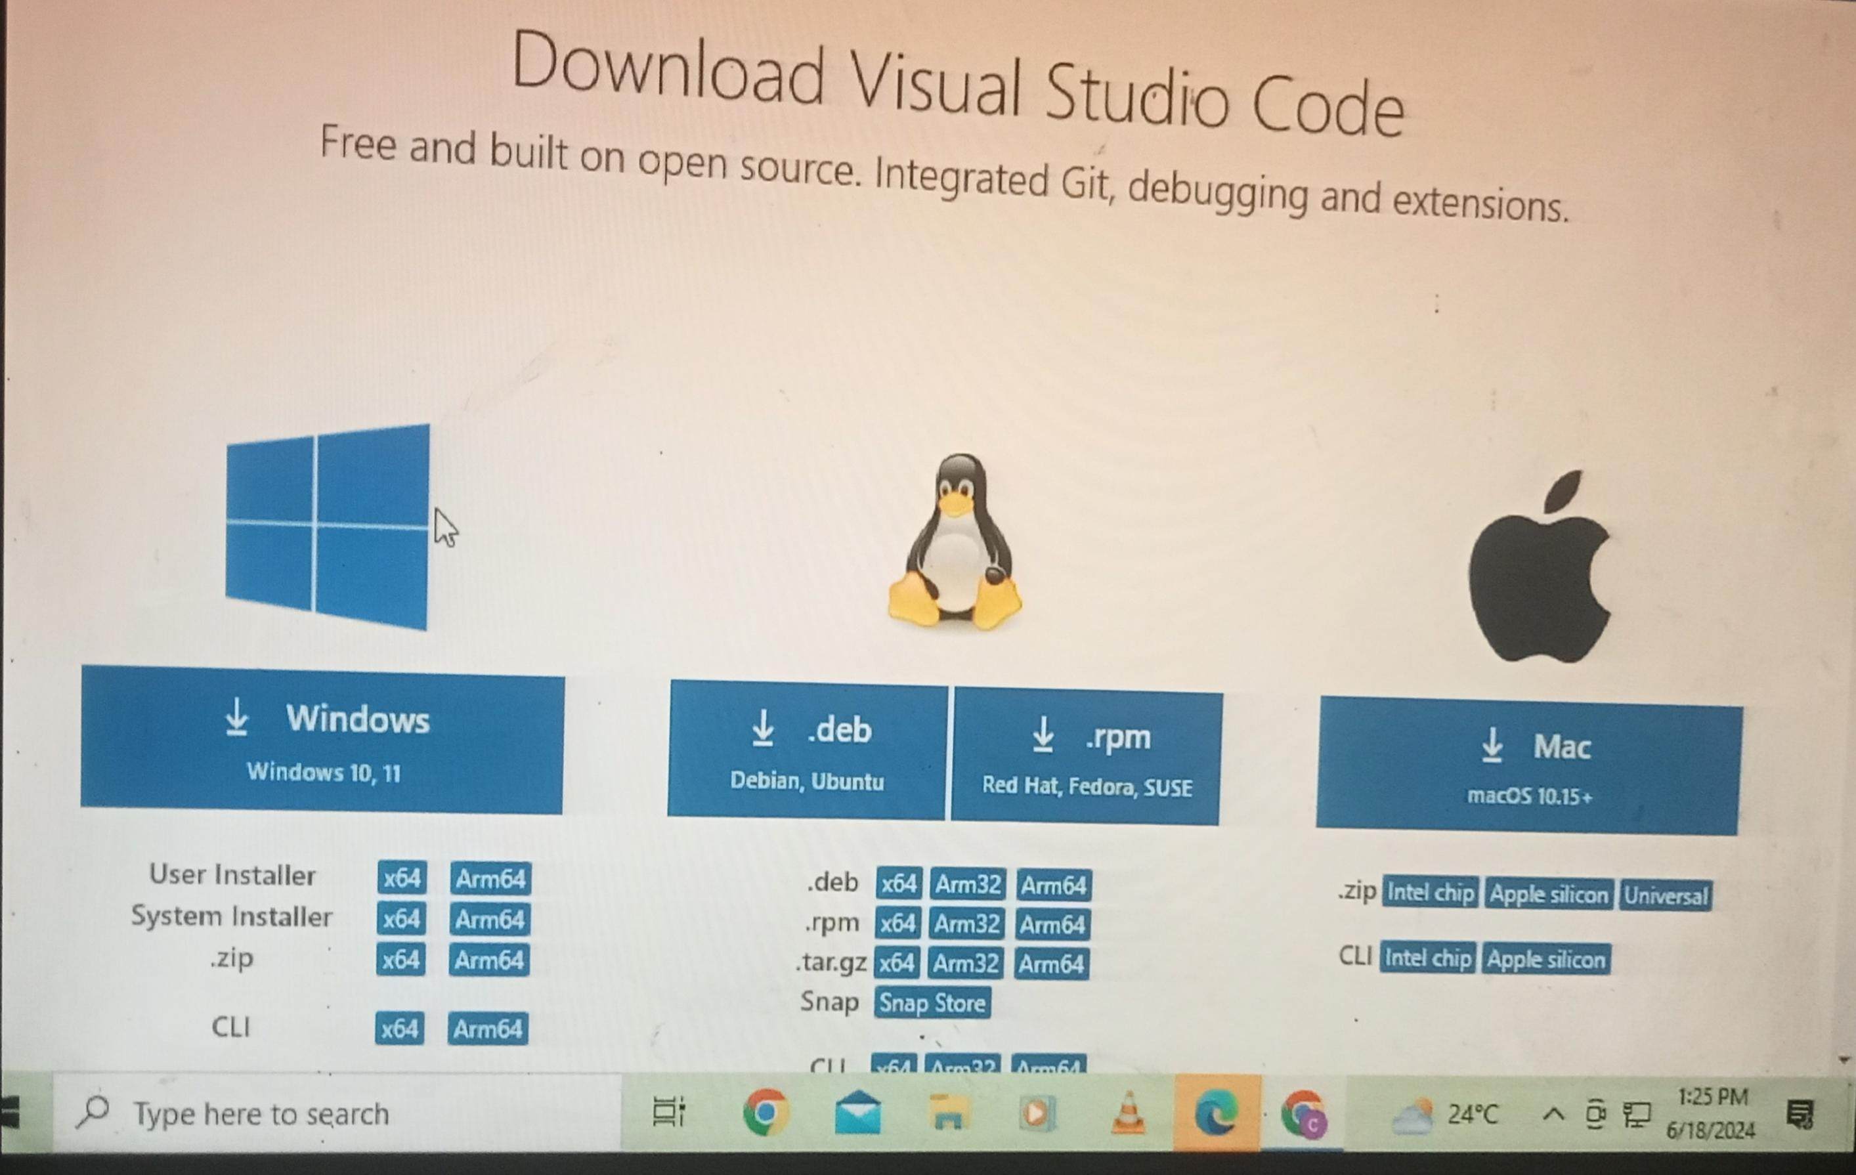2. Run the Installer:

- Once the download is complete, open the installer.

- Follow the prompts in the setup wizard. Agree to the license agreement and choose your desired install location.

3. Launch Visual Studio Code:

- After installation, you can launch Visual Studio Code from your applications or programs list.

4. Optional – Install Extensions:

- Visual Studio Code has a feature called ‘Extensions’ which allows you to add languages, debuggers, and tools to your installation to support your development workflow.

That’s it! I am ready to start coding with Visual Studio Code.

Set Up Version Control System: Install Git and configure it on your local machine. Create a GitHub account for hosting your repositories. Initialize a Git repository for your project and make your first commit. <https://github.com>

1. Install Git:

- Go to [git-scm.com](<https://git-scm.com/>).

Click on the “Downloads” section and select the version suitable for your operating system.

Once the installer is downloaded, run it and follow the installation prompts.

2. Create a GitHub Account:

- Visit [github.com](<https://github.com/>).

- Click on “Sign up” and fill in the required details.

-Verify your email address to complete the account setup.

3. Initialize a Git Repository:

- Open your project folder in VS Code.

- Open the integrated terminal in VS Code (you can use the shortcut `Ctrl + ``).

- Type `git init` and press Enter. This will create a new Git repository in your project folder.

Remember to configure your Git with your username and email using the following commands in the terminal:

Git config –global user. Name “adenyac”

Git config –global user. Email adenyac000@gmail.com

This will associate my commits with my identity on GitHub.

Install Necessary Programming Languages and Runtimes: Instal Python from <http://wwww.python.org> programming language required for your project and install their respective compilers, interpreters, or runtimes. Ensure you have the necessary tools to build and execute your code

1. Go to the official Python website: [python.org](<https://www.python.org/>).

2. Navigate to the ‘Downloads’ section.

3. Choose the version suitable for your operating system (Windows, macOS, or Linux/UNIX).

4. After downloading the installer, run it.

5. During installation, make sure to check the box that says “Add Python to PATH” before you click “Install Now”.

6. Follow the rest of the prompts to complete the installation.

After installation, I can verify that Python is installed correctly by opening my command line (cmd on Windows, Terminal on macOS and Linux) and typing `python –version`. I should see the Python version number that I installed.

Install Package Managers: If applicable, install package managers like pip (Python).

1. Download get-pip.py:

- Visit the link [bootstrap.pypa.io/get-pip.py](<https://bootstrap.pypa.io/get-pip.py>) on your browser.

Right-click on the page and select “Save As” to download the `get-pip.py` file to your computer.

2. Install pip:

Open your command prompt (cmd) or terminal.

Navigate to the directory where you downloaded `get-pip.py`.

Run the following command: `python get-pip.py`

This will install pip on my system, and I should see a success message in the command prompt or terminal once it’s installed.

Remember, you might need to use `python3` instead of `python` if you have both Python 2 and Python 3 installed on your system. Also, if you’re using Linux or MacOS, you might need to use `sudo` for administrative privileges: `sudo python get-pip.py`.

Configure a Database (MySQL): Download and install MySQL database. <https://dev.mysql.com/downloads/windows/installer/5.7.html>

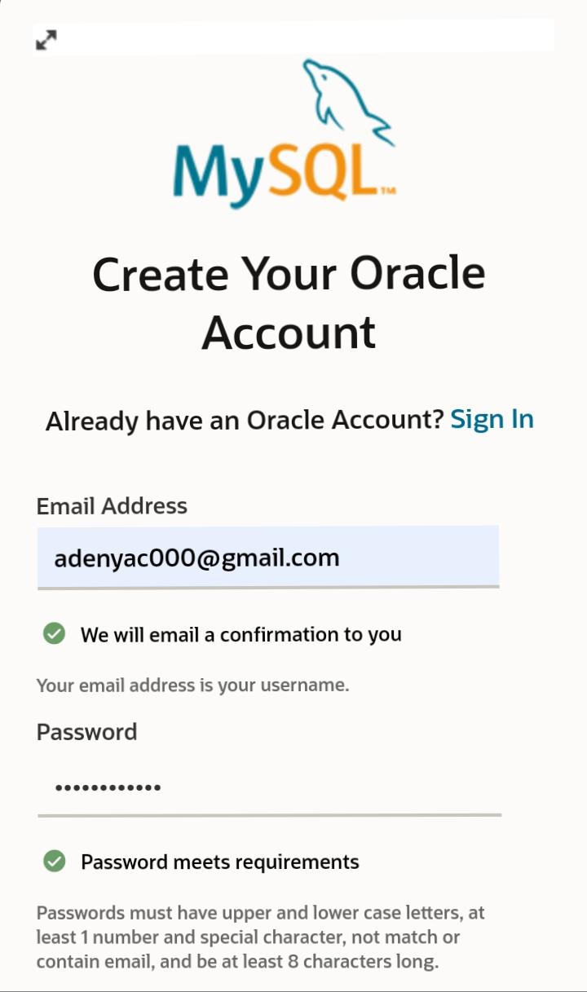

1. Go to the MySQL website at [mysql.com](<https://dev.mysql.com/downloads/windows/installer/5.7.html>).

2. Choose the version of MySQL that you want to download. If you’re unsure, the website usually recommends a version.

3. Click on “Download” for the installer.

4. You may be asked to sign up or log in to an Oracle account, but this is usually optional. Look for a link that says “No thanks, just start my download” if you don’t want to sign up.

5. Once the installer is downloaded, run it.

6. The installer will guide you through the setup process. You can choose a typical installation or customize it based on your needs.

7. During installation, you’ll be prompted to set a root password for the MySQL server. Make sure to remember this password as it’s important for accessing and managing your databases.

8. After installation, you can use the MySQL Workbench or command line client to manage your databases.

Explore Extensions and Plugins: Explore available extensions, plugins, and add-ons for your chosen text editor or IDE to enhance functionality, such as syntax highlighting, linting, code formatting, and version control integration.